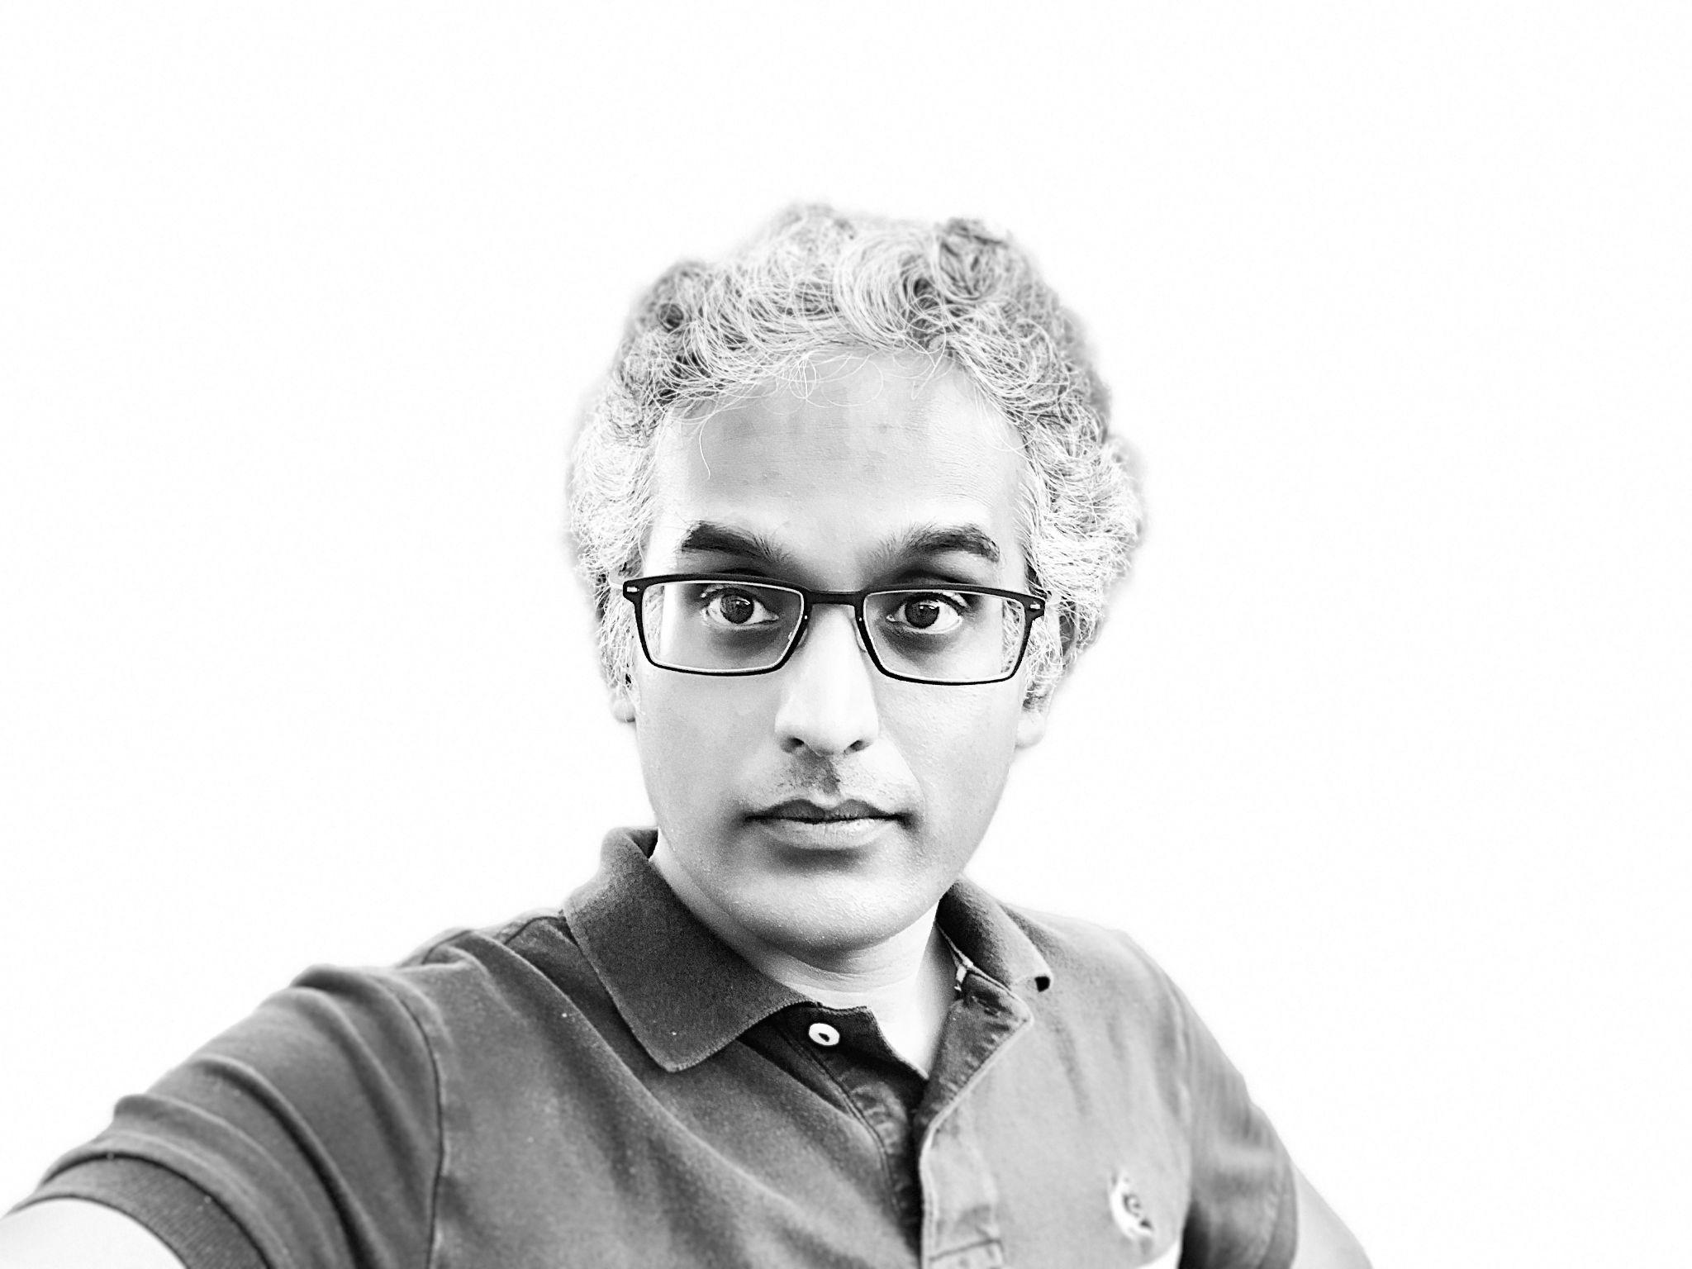
Krish Palaniappan
Software Architect, CTO, Developer

krish@snowpal.software
571.721.9722 (Text/Call)

- Manage Projects on https://snowpal.com
- Download iOS and Android Apps
- LinkedIn Recommendations

Summary

I’ve been building Software for over 2 decades now, and have therefore done a fair bit of development and architecture work across a number of stacks, in addition to playing a number of different roles in companies of varying sizes.

A few different ways I can help.
- Web or Mobile UI Development.
- Creating APIs using GraphQL or REST.
- UI or Server Side Architecture.
- Server Side Integration or SSO.
- Leading Engineering Teams.

Other Interests

- Teaching, Technical Podcast
- Blog, Medium, YouTube, Vimeo
- Animated ADs

Experience

When | Who (Role, Client) | What (Responsibilities) | How (Technologies)
01/16 to Present | CTO, Snowpal | Lead the engineering team and am responsible for all aspects of development.  Check out our Web App, iOS App, Android App, and API Gateway (coming soon). | Flutter, Dart, React, NestJS, Ruby on Rails, Sinatra, Node.js, MongoDB, RabbitMQ, AWS, Lambda, REST, Heroku, CoffeeScript, Backbone, Handlebars, Haml, Gulp
05/22 to  11/22 | Senior Software Developer, Outreach | Worked on Ruby on Rails development. And a fair bit of Go! | Ruby on Rails, Go, RSpec, MySQL, Postgres, Kubernetes,  Datadog, Honeycomb
11/21 to  04/22 | Node Architect & Developer, Aon | Worked on design, architecture, development & deployment of Node/NestJS  applications. | Node, NestJS, MongoDB, Kafka, Kubernetes, Mongoose,  TypeScript, Azure
02/21 to  10/21 | Senior Staff Software Engineer, RunaHR | Led teams and implemented a variety of polyglot, full stack applications and  micro services. | Express, Node, GraphQL, Ruby on Rails, React, TypeScript,  PostgreSQL, MongoDB
09/20 to  12/20 | React Developer, Walmart | Worked on the development of React Applications. A pure UI-only role for  perhaps for the first time in my career. | React, TypeScript, Node, Jest, Prometheus, Grafana, Splunk
08/18 to  12/18 | Node Developer & Rails Architect, Snowpal | Worked on a couple of short term projects building a variety of  Node/Rails/React applications. | React, Ruby on Rails, PostgreSQL, Node, Heroku
12/17 to 05/18 | Node Architect, Involta | Worked on several aspects of (mobile & server side) development starting  with flushing out requirements, defining the architecture (of several apps),  creating the design, and doing the actual development and deployment,  amongst other things. | Node.js, Express, GraphQL, MongoDB, Linux, EC2, OAuth,  MySQL, AWS, ETL
06/10 to  11/17 | Ruby Architect, DC Healthlink | Worked on the design, architecture & development of Ruby on Rails &  Sinatra applications. | Ruby on Rails, Mongoid, Sinatra, MongoDB, Shell Scripting,  AWS, Linux, REST, EC2, RSpec
06/15 to  09/16 | Ruby on Rails Architect, FireEye | Worked on the architecture, design, development & deployment of Ruby on  Rails applications. | Ruby on Rails, PostgreSQL, REST, Linux, Shell scripts
02/16 to  04/16 | Java Architect, CSRA | Worked on analyzing the design, architecture, performance, scalability and  maintainability of a production JEE application with the ultimate aim of  identifying issues and areas of improvement across the board. | ReactJS, Spring, Hibernate, AOP, SQL, JavaScript, Web  Services, Tomcat, Git, IntelliJ
10/14 to  01/16 | Java Architect, Fannie Mae | Worked on providing Development & Architectural guidance for JEE  applications. | JEE, Java, Spring, Hibernate, Backbone.js, Oracle, Eclipse,  JavaScript, CSS, jQuery, REST, XML, Dynatrace, WebSockets, Jackson,  JSON
06/14 to  01/16 | Senior Ruby Developer, GCI | Worked on the design, development and deployment of Ruby & Rack  Applications. | Ruby, Sinatra, Rack, Rails, REST, MySQL, JavaScript, jQuery,  HAML, RubyMine, Neat/Bitters/Bourbon, RabbitMQ, D3.js, CoffeeScript
01/14 to  05/14 | Ruby Architect, Neural ID | Worked on the architecture, design, development & deployment of distributed  Check out our SaaS App by signing up on https://snowpal.com. Remember to download the Mobile App from App/Play stores.  Ruby Web Applications on the Amazon EC2 Cloud. | Ruby, Sinatra, Node.js, Memcached, Rack, Passenger,  Apache, Nginx, MongoDB, Mongoid, WebSockets, S3, REST, Trello/Apiary,  AWS/EC2, aws-sdk
11/12 to 12/13 | Senior Ruby Developer, GCI | Worked on the architecture, design, development & deployment of Ruby  applications. | Sinatra, Ruby, Rack, MySQL, JMeter, RubyMine, Node.js,  Express, JavaScript, Bitbucket, Mercurial, Git
04/11 to  10/12 | Senior Java Developer, Synapse Group | Worked on the design, development, architecture and tuning of a clustered  JSF-based JBoss Portal application, running against an Oracle instance, for  a large media client. | JSF, RichFaces, JEE, JBoss Portal, Spring, Hibernate, Apache  Web Server, JBoss AS, Clustering, Caching, Oracle, Ant, Portlets, ShellScripts, Git, Confluence, Jira, VisualVM, Eclipse MAT
06/10 to 05/11 | Senior Java Architect  Northrop Grumman | Worked on building n-tier, distributed, SOA-based JEE applications. | Struts2, Spring, Hibernate, JEE, Oracle, ActiveMQ, CXF,  SiteMesh, Camel, ServiceMix, Liferay Portal, RHEL, Eclipse, Java, Ant, Maven, JUnit, Mockito, JAAS, JBoss, SVN, SOA, Web Services, ESB, Luntbuild
04/10 to  06/10 | Java Architect, Fannie Mae | Worked on identifying requirements, proposing alternatives, making technology choices and defining the architecture for a suite of applications. | JBoss AS, Java, Oracle
12/09 to  04/10 | Senior Java Developer  Northrop Grumman | Worked on building Java Spring/Tapestry applications. | Spring, Hibernate, Tapestry, Oracle, Tomcat, Web Services  (SOAP), Eclipse, SVN, JUnit, EasyMock, Maven, Linux, Mockito
06/07 to  11/09 | Senior Software Developer  Grab Networks | Worked on designing, architecting and developing both Ruby on Rails and  JEE applications (in addition to leading teams). | Struts, JBoss, Ruby on Rails, Oracle, Tomcat, Ant, Java, JEE,  JAAS, CAS (SSO), JDBC, JSP, JSTL, Spring, Hibernate, Linux, JBoss Portal,  CAS, ActiveMQ, MySQL, Capistrano, openWFEru
01/07 to  06/07 | Senior Java Developer, Sunrocket | Worked on the design and development of Service-Oriented Architecture  (SOA) applications. | JEE, Spring, Hibernate, Java, MySQL, Tomcat, Apache,  JBoss, jBPM, JMS, EJB (MDB), Linux, XMLBeans, Ant, Ivy
04/01 to  11/06 | Principal Member of Technical Staff  Oracle | Worked in the esteemed Server Technologies division for multiple products  and had a wonderful employment experience working with some of the best  minds in the business. | Java, Oracle, JavaScript, XQuery, XPath, XML, JDBC, JOC,  PL/SQL, Ant, JSR-168/170, Oracle AS, Oracle Portal, Oracle WebCenter  Suite
09/99 to  04/01 | Software Developer  Diebold Nixdorf | This was my very first software development job but had the opportunity to  work on multiple products based on 2 completely different technology stacks  (C & JEE). | JEE, Java, Oracle, AIX, Pro*C, HTML, XML, XSLT, Xalan,  XSD, JavaScript, JSP, XPath

Education

- Master’s in Hospitality Management, University of Houston, TX
- Master’s in Management Studies, BITS, Pilani, India
- Master’s in Biological Sciences (Hons), BITS, Pilani, India

